# CHAPTER III

# PROBLEM ANALYSIS

## III.1. Github repository

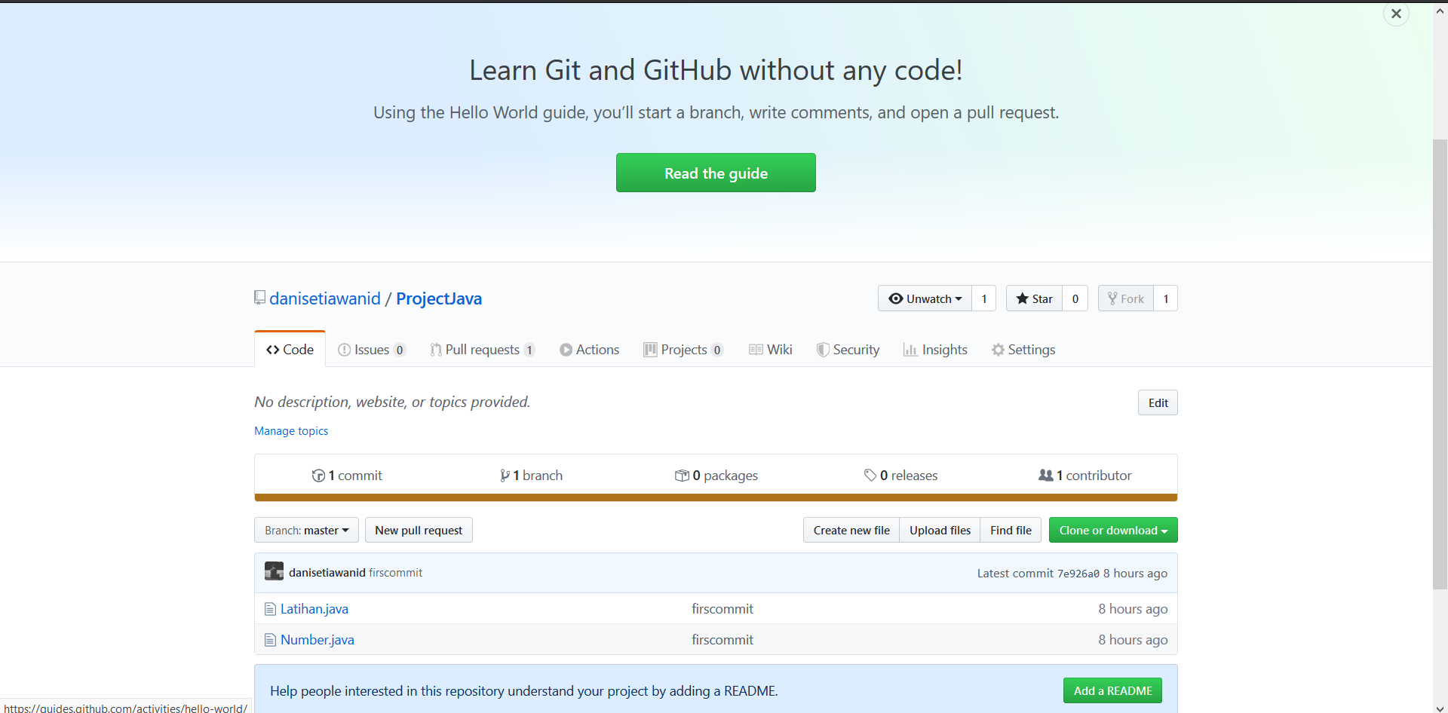

**Figures 3.1 GitHub Repository 1**

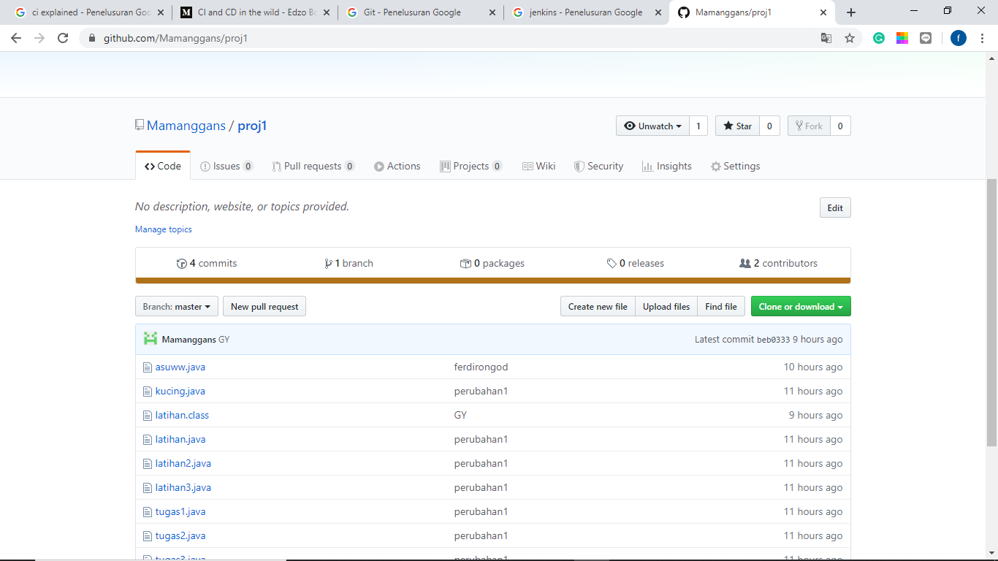

**Figures 3.2 GitHub Repository 2**

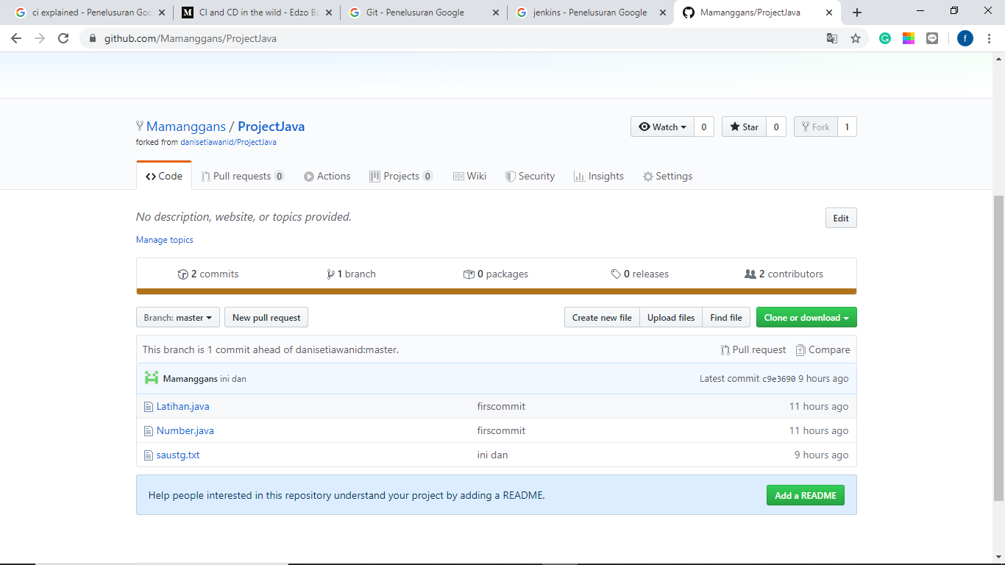

**Figures 3.3 GitHub Repository 2 for forked project**

**III.4 Jenkins**

After pushing the README file ,Jenkins will automaticly build and test the Program

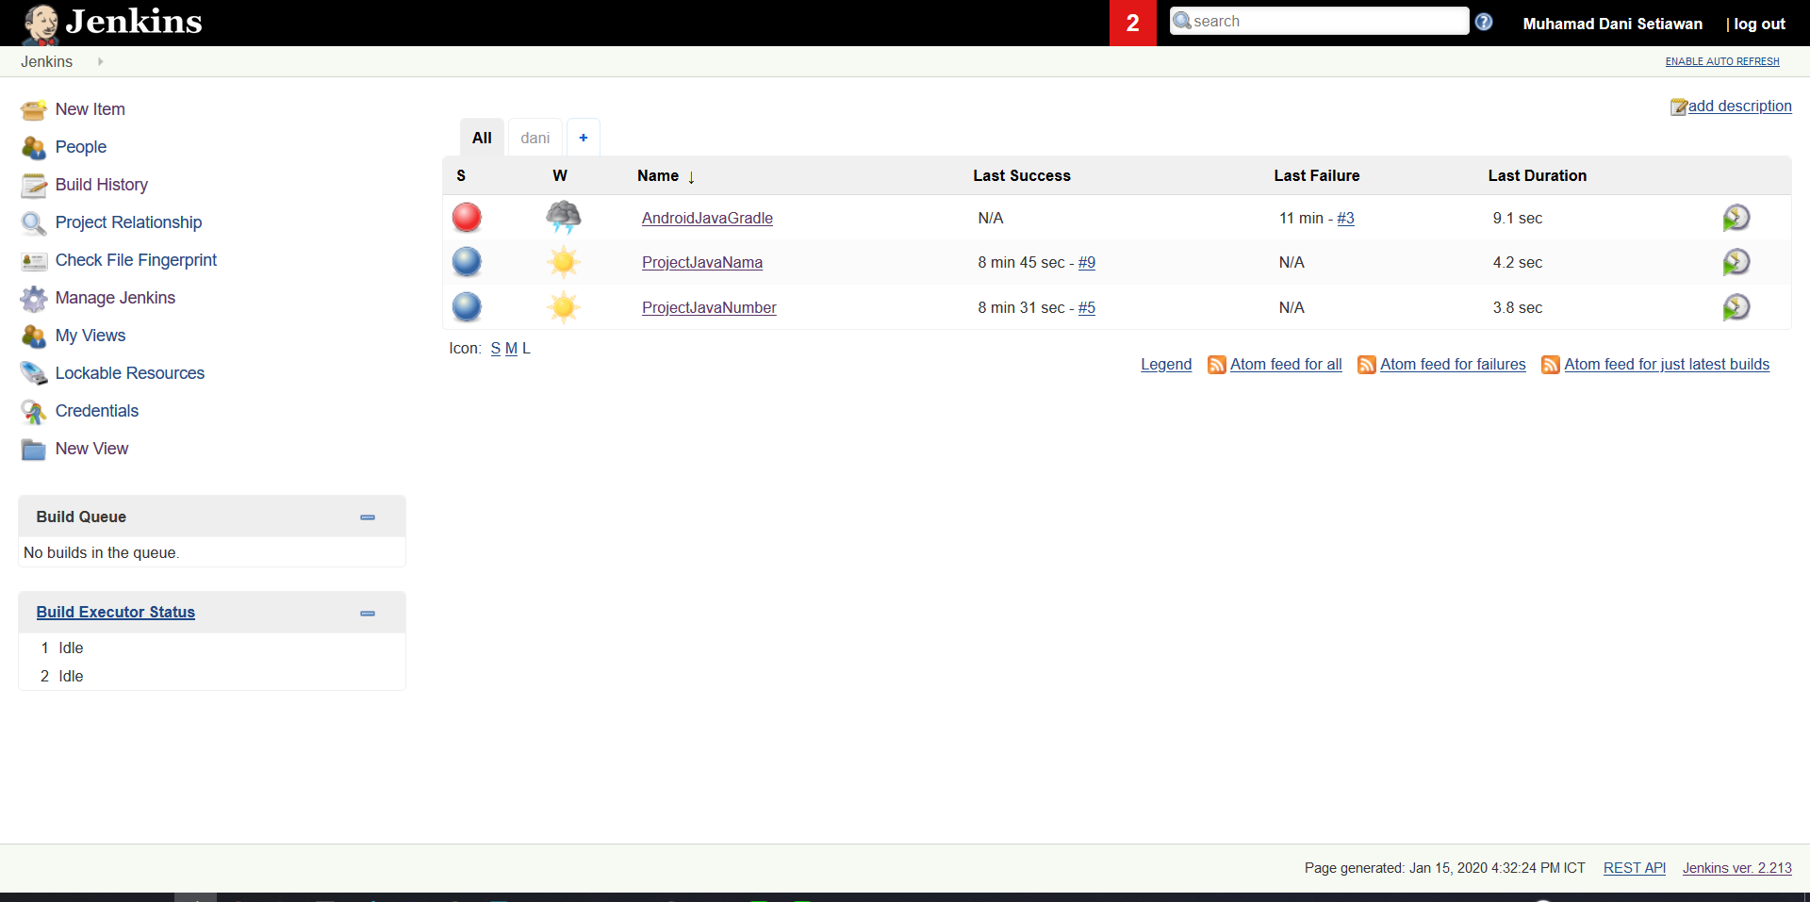

**Figures 3.4 Jenkins**

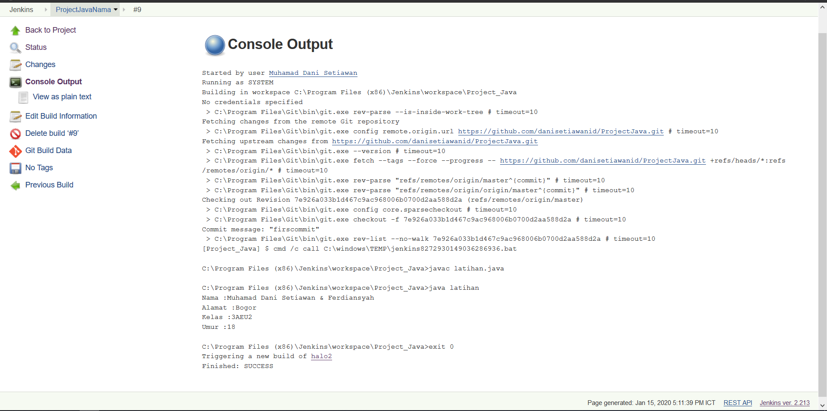

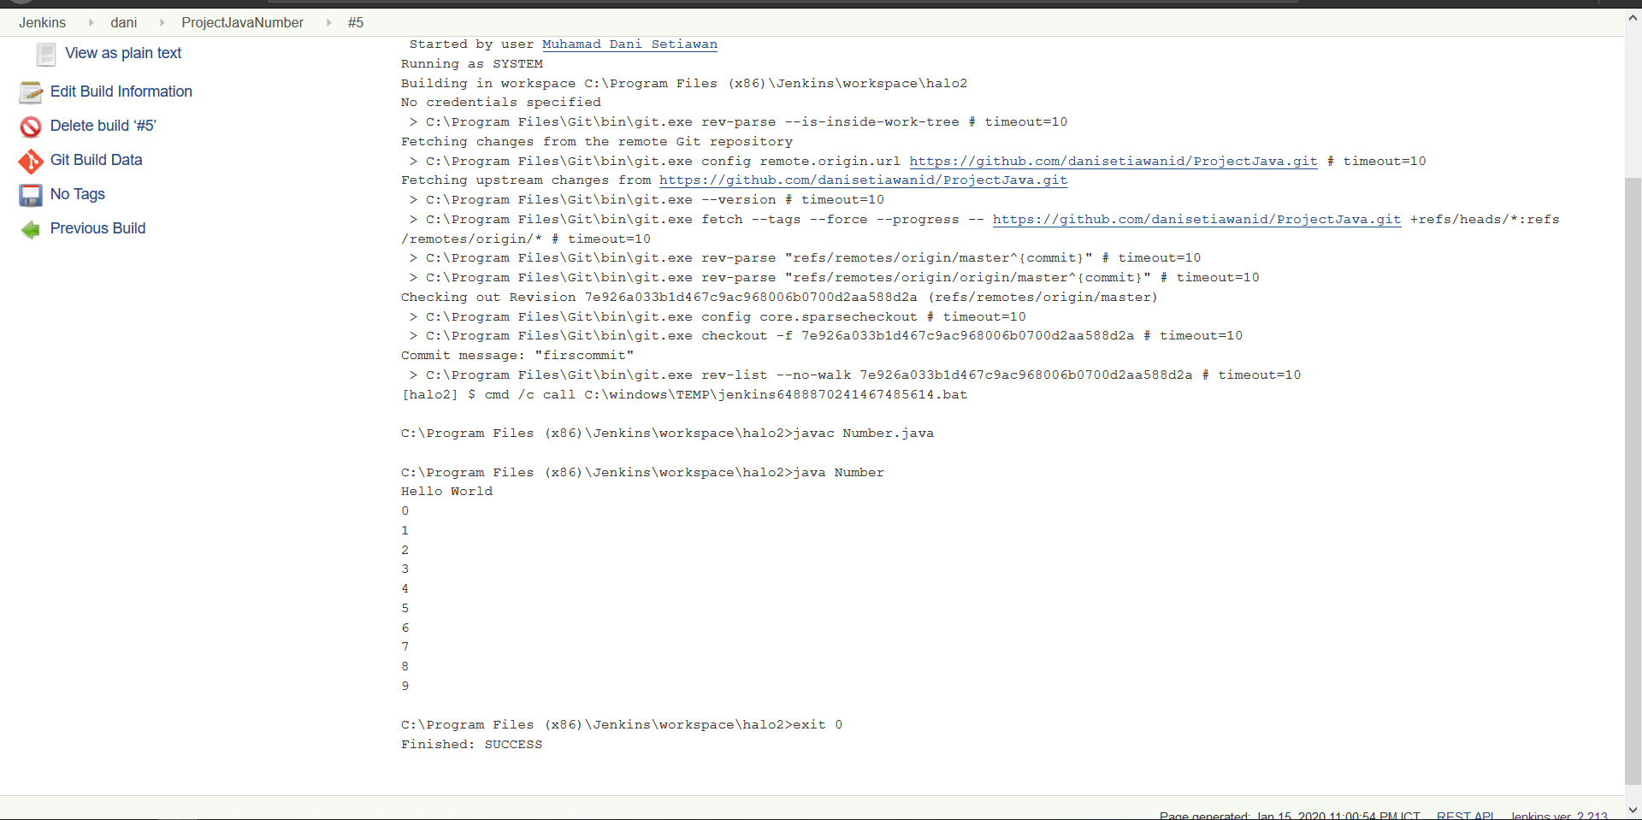Figures 3.5 Jenkins consol output

Figures 3.6 Jenkins consol output 2

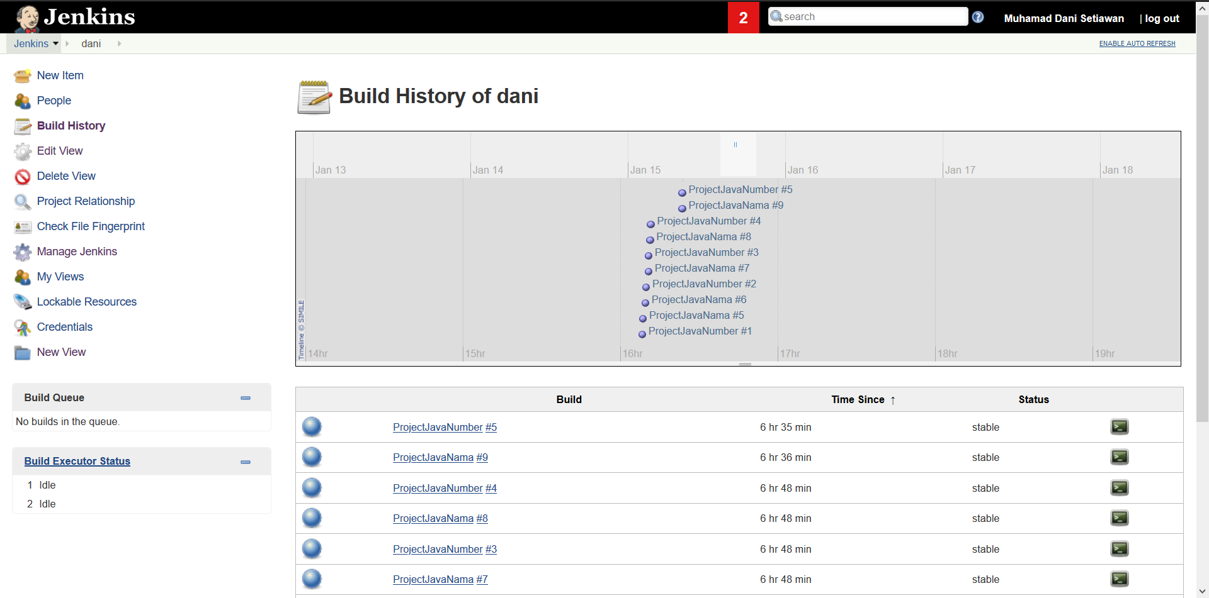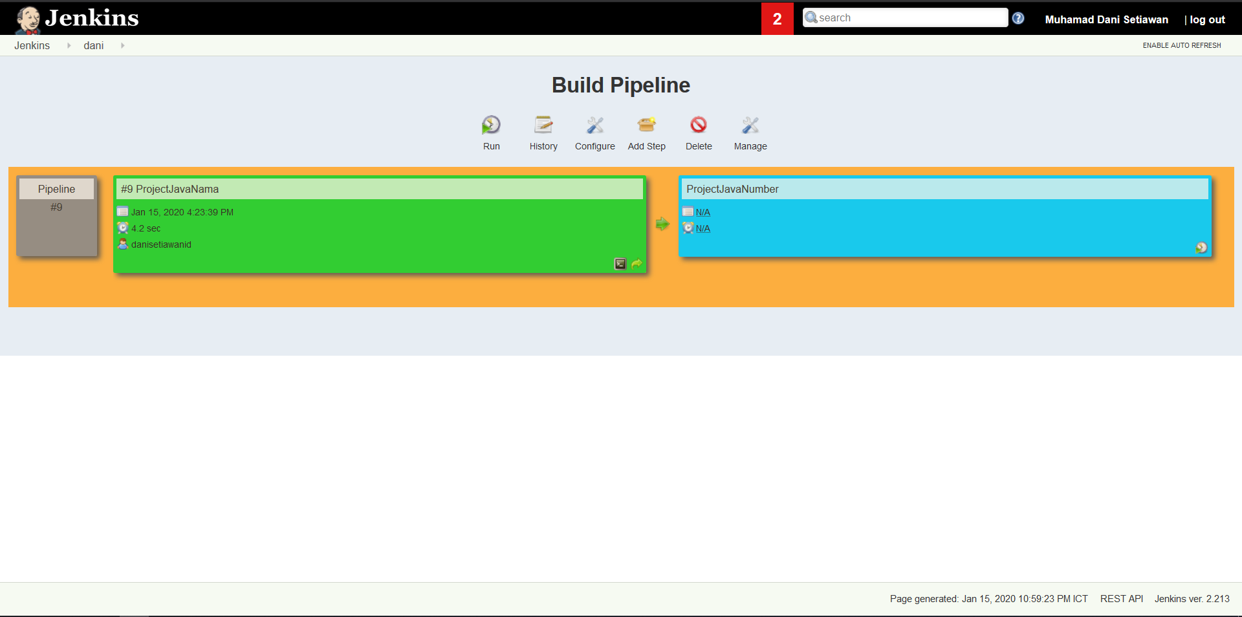Figures 3.7 Jenkins pipeline

Figure 3.8 Jenkins pipeline history

# CHAPTER IV

# CONCLUSION AND SUGGESTION

## IV.1. Conclusion

Jenkins is an open source automation server written in Java. Jenkins helps to automate the non-human part of the software development process, with continuous integration and facilitating technical aspects of continuous delivery.

GitHub is a web-based hosting service for version control using Git. It is mostly used for computer code. It offers all of the distributed version control and source code management (SCM) functionality of Git as well as adding its own features

## IV.2. Suggestion

in our opinion, in this paper there are still many shortcomings due to our little knowledge of haversine formulas so we expect suggestions from readers for improvement of our papers